Week-3
Task-1
Lab 1: Understanding ORM with a Retail Inventory System

using RetailInventorySystem.Models;
using System;
using System.Linq;

class Program
{
static void Main()
{
using var context = new RetailContext();

// Ensure database is created
context.Database.EnsureCreated();

// Seed data only if Products table is empty
if (!context.Products.Any())
{
var products = new[]
{
new Product { Name = "Laptop", Quantity = 10, Price = 75000 },
new Product { Name = "Mouse", Quantity = 50, Price = 700 },
new Product { Name = "Keyboard", Quantity = 30, Price = 1500 },
new Product { Name = "Monitor", Quantity = 15, Price = 12000 }
};

context.Products.AddRange(products);
context.SaveChanges();
Console.WriteLine("✅ Initial products added to database.\n");
}

// Retrieve and display all products
Console.WriteLine("📦 Product Inventory:\n");
var productList = context.Products.ToList();
foreach (var product in productList)
{
Console.WriteLine($"🆔 {product.ProductId} | 📌 {product.Name} | 📦 Qty: {product.Quantity} | 💵 ₹{product.Price}");
}
}
}

Output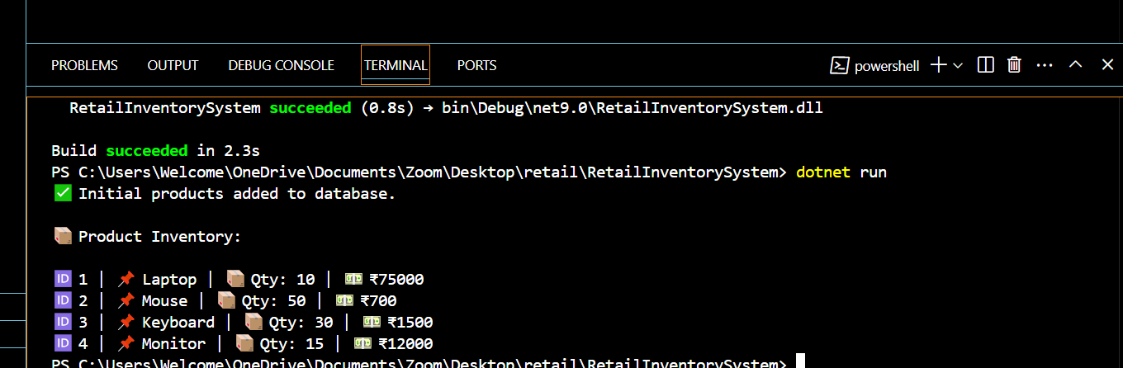

Name:Ayushman Upadhyay
Email:2230164@kiit.ac.in
Superset Id: 6358125

